Module 1 Game, Design Document v2

**Revenge of the virus**

1. What is the feeling you are trying to invoke?

We want the player to feel like they want to beat it. The player should be determined to get to the end of the level or mission and be able to accomplish the goal with a high level of satisfaction.

1. What are your top 2-3 player experience goals, which will invoke that feeling?
2. 1.) Death

a.) Several ways to die which include by enemies, environment, and/or time-limit. b.) Each way to die will have different death animations.

c.) Each death will come with a consequence.

2.) Difficulty

a.) Constant barrage of enemies b.) Enemy behavior c.)Environment obstacles/behavior

3.) Fun

a.) power ups to help your quest

b.) different type enemies/difficulty keeps the game fresh and innovative

1. Elevator pitch: describe your game to a potential investor in 20 seconds or less

Can a virus feel? Cause this one can and its out for revenge against the tyranny of the bacteria that killed his father. Control this young virus as it learns to kill the bacteria and becomes a cold blooded killer. Will he be able to avenge his father? Only you can decide.

1. What are the formal elements of your design, and how do they contribute to the experience goals? (Since this is a development/art class, pay particular attention to how the underlying simulation and the visual aesthetic contribute)
   1. **Players**

1 player

# Objectives

Infect the bacteria while surviving

# Procedures

Move left, right, and jump with the character and use different attacks to kill enemies

# Rules

Stay in the screen area. Have fun ; )

# Conflicts

Enemies, environment, and time

# Boundaries

Stay within in the map which is in the screen

# Outcomes

Beat the bacteria hence multiplying the virus

1. List the actions that the player can take (e.g. jump, place block, click on enemy) and what additional feedback the player will get to know that they did it (e.g. sounds, flashes highlighting, pop-ups).
2. Jump
3. Attack
4. List the significant events that can happen (e.g. fall, hit something, solve a puzzle) and what additional feedback the player will get.

1.) Death

Respawn from beginning

2.) Taking damage

Health-drop

3.) Power-ups

Each power up with have its own unique feedback (e.g. health or shield)

4.) Falling into pits

Respawn from beginning

1. List the pieces of information that your user interface needs to communicate to the player.

1.) Health bar

2.) Duration of power up

1. Attach rough “screenshot” sketches showing the layout of different visual elements in the game world and user interface. Annotate with functionality. Everyone contribute, not just the artists!  
   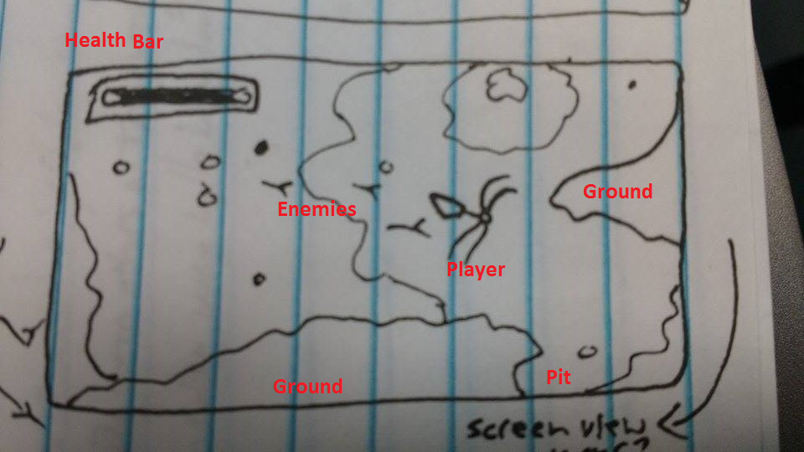
2. Asset Control List

Keep a master list of all the art assets required for the game. Note whether they will be created or borrowed. (examples below)

1.)Player

a.)moving in two directions

b.) jumping

c.)Attacks in four cardinal directions

d.)Standing still

Environment

1. Platforms
2. Background

Enemies

a.)Movement

Power Ups

Health bar frame and fill